# Certificate of Recognition

The College of Computing and Informatics presents its sincere gratitude and appreciation to

Mahaz Ishtiaq khan

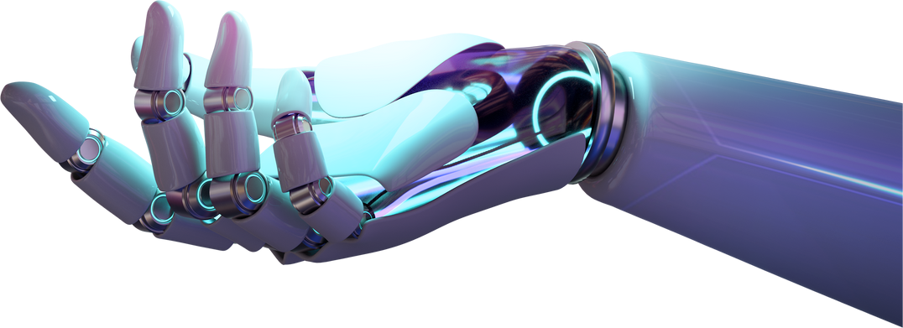For attending and participating in the CCI Week 2025, held between 21-22, April 2025

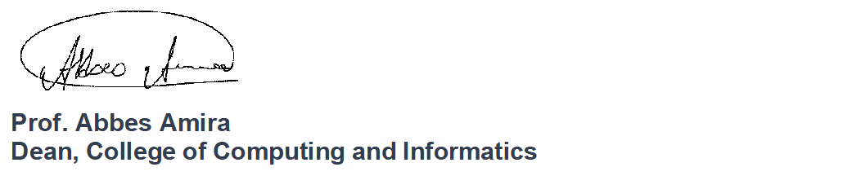

CCI

**WEEK**

**2025**